**Robot Design Documentation**

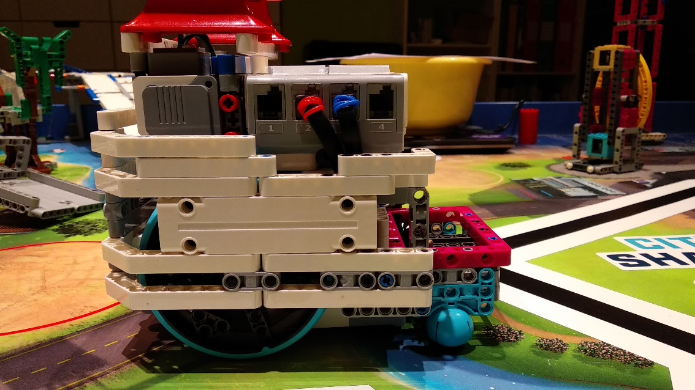Team TövisASAP 2019-20   
Documentation for our great and innovative **SNEAKY** robot  
**Modular, Stable, Precise, Gentle  
S.D.P.S.I.**

Software

Software

**Systematic Design Process for Strategy and Innovation**

**Pre-Season  
Design System**

**We have applied**

**Systematic Design Process for Strategy and Innovation  
S.D.P.S.I.**

**In-Season  
Design System**

**Robot Strategy improvements || regional 🡪 SF**

|  |  |  |
| --- | --- | --- |
| Round name | Regional Round Version | Semi Final Version – with improvements |
| Round „Treebat”  (Now we call this round „Crane” because we connected it to mission „Crane”) | It was full of movement that’s why it was too slow and inaccurate. | Now we are using a more complex attachment with pneumatics so we **don’t need to navigate that much** so it became simpler and we **connected** this round to round „Crane”. |
| Round „Bee”  (We do not have this round anymore, we connected it to round „South”) | It was also full of movement so it was 1 minute long, it was just 65 points and it was also inaccurate | We **connected** it to mission „South” so the **point/second rate of this mission is now better**. We take up a new task, mission Elevator and we made this whole round **more accurate** |
| Round „South” | It was too complicated and this was the cause of mistakes. This attachment had many weak points beacause of its complexity | Now it is **simpler** because we use just **passive solutions** and it is **more accurate** because we align many times to the wall or to lines. |
| Round „Bridge” | It was a good and reliable round but we had difficulties with the gear transmission because it was too weak and the movement of this arm was too inaccurate. And we had some problems with the solution that pushes down the flags, it was unreliable | We changed the thing on the attachment that pushes down the flags so it is **more reliable**. We also **changed the gear transmission** and now it is stronger and more accurate. |

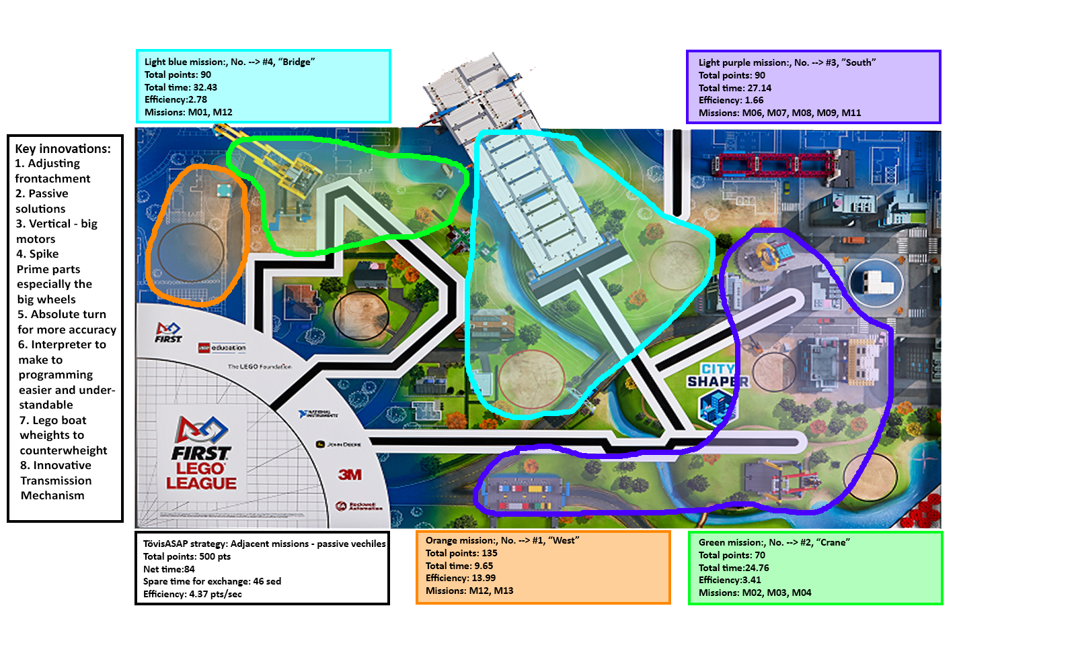**Mission Strategy – SF(improved)**

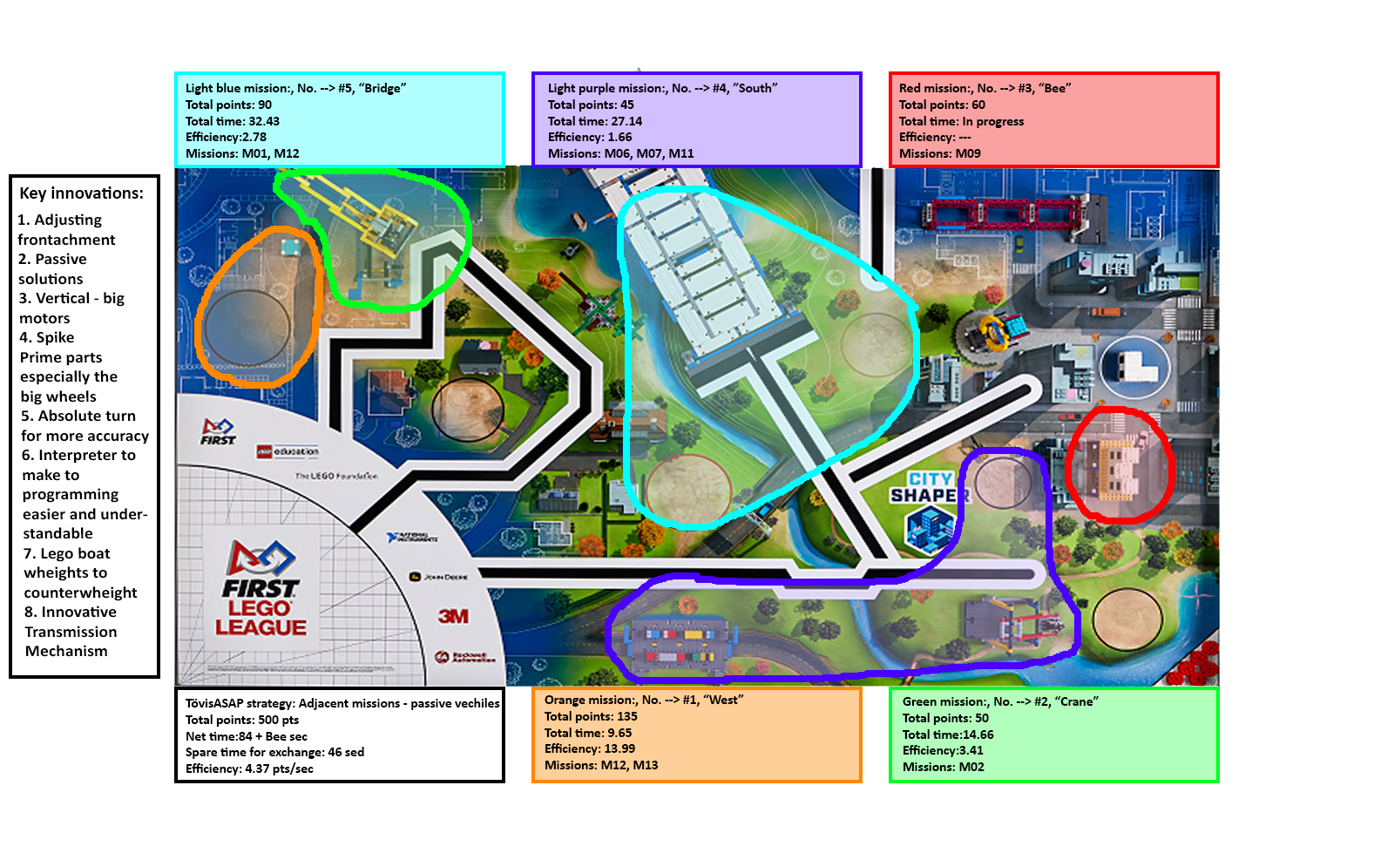**Mission Strategy – Regional(old)**



Our goal: very clear, purposefully to maximize points

**Mission Efficiency – SF**

|  |  |  |  |  |  |  |
| --- | --- | --- | --- | --- | --- | --- |
| **Round** | **Mission** | **Points** | **Total points** | **Time(sec)** | **Run safety(%)** | **Points/sec** |
| 0.round |  |  | 45 | ------ | ------ | ------ |
|  | Advantage(8 missions + M02 bonus) | 45 |  |  |  |  |
| 1.Round |  |  | 135 | 9.65 | 85 | 13.99 |
| West | Design & Build(SumHeight: 21) | 105 |  |  |  |  |
|  | Sustainability upgrades x3 | 30 |  |  |  |  |
| 2.Round |  |  | 50 | 14.66 | 95 | 3.41 |
| Crane | Crane | 50 |  |  |  |  |
| 3.Round |  |  | 60 | In progress |  |  |
| Bee | Safety factor | 60 |  |  |  |  |
| 4.Round |  |  | 45 | 27.14 | 80 | 1.66 |
| South | Traffic Jam | 10 |  |  |  |  |
|  | Swing | 20 |  |  |  |  |
|  | Innovative Architecture | 15 |  |  |  |  |
| 5.Round |  |  | 90 | 32.43 | 90 | 2.78 |
| Bridge | Design & Build(2 colors) | 40 |  |  |  |  |
|  | Elevated Places | 50 |  |  |  |  |
| Extra points |  |  | 75 | ------ | ------ | ------ |
|  | Design & Build(1 color) | 10 |  |  |  |  |
|  | Design & Build(SumHeight: 1) | 5 |  |  |  |  |
|  | Precision | 60 |  |  |  |  |
| Total |  |  | 500 | 83.88+Bee | 87.5 | 4.368 |

**Mission Strategy**

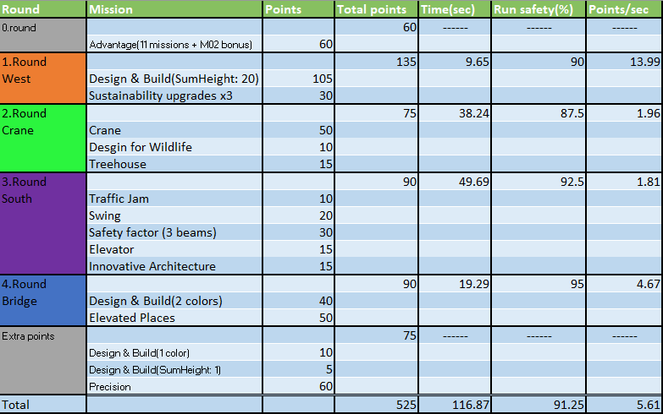We divide the mat, like this we could established the most effective rounds. We measured the **point/second** progress too, so we know in witch round to optimize.

**Mission Strategy**

**Mission Strategy**

**Mission Efficiency - regional**

|  |  |  |  |  |  |  |
| --- | --- | --- | --- | --- | --- | --- |
| **Round** | **Mission** | **Points** | **Total points** | **Time(sec)** | **Run safety(%)** | **Points/sec** |
| 0.round |  |  | 45 | ------ | ------ | ------ |
|  | Advantage(8 missions + M02 bonus) | 45 |  |  |  |  |
| 1.Round |  |  | 135 | 9.65 | 85 | 13.99 |
| West | Design & Build(SumHeight: 21) | 105 |  |  |  |  |
|  | Sustainability upgrades x3 | 30 |  |  |  |  |
| 2.Round |  |  | 50 | 14.66 | 95 | 3.41 |
| Crane | Crane | 50 |  |  |  |  |
| 3.Round |  |  | 60 | In progress |  |  |
| Bee | Safety factor | 60 |  |  |  |  |
| 4.Round |  |  | 45 | 27.14 | 80 | 1.66 |
| South | Traffic Jam | 10 |  |  |  |  |
|  | Swing | 20 |  |  |  |  |
|  | Innovative Architecture | 15 |  |  |  |  |
| 5.Round |  |  | 90 | 32.43 | 90 | 2.78 |
| Bridge | Design & Build(2 colors) | 40 |  |  |  |  |
|  | Elevated Places | 50 |  |  |  |  |
| Extra points |  |  | 75 | ------ | ------ | ------ |
|  | Design & Build(1 color) | 10 |  |  |  |  |
|  | Design & Build(SumHeight: 1) | 5 |  |  |  |  |
|  | Precision | 60 |  |  |  |  |
| Total |  |  | 500 | 83.88+Bee | 87.5 | 4.368 |

**Mission Strategy**

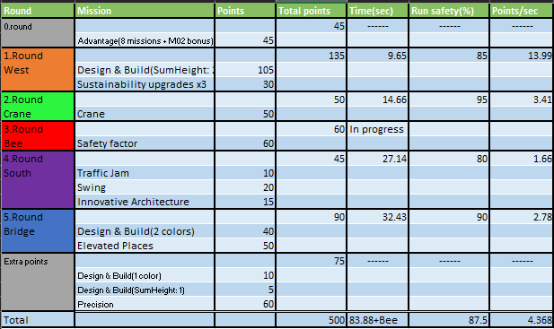

**Attachments and Front-achments for Base robot**

|  |  |
| --- | --- |
|  | Attachment |
| 1.Round West | Tractor |
| 2.Round Crane | Farmer |
| 3.Round South | Lifter |
| 4.Round Bridge | Candy |

**Reliability**

Our goal: excellent, novel, outgoing, successful in each task

Our goal: excellent, novel, outgoing, successful in each task

* Our Robot tries to successfully solve all tasks
* It solves logically-related tasks with proper and newly designed attachments
* Our robot does not need to be saved in any round
* We are proud for our programs, the result of many of our work E.g.:
  + **DRV, TU, ToCm and the whole interpreter**
* There is no planned destruction in our program
* **We can easily exit from any program using MasterMenu**
* We use the most similar motors and sensors as possible to reduce the chance of mistake from the difference between motors and sensors
* Our Robot tries to successfully solve all tasks
* It solves logically-related tasks with proper and newly designed attachments
* Our robot does not need to be saved in any round
* We are proud for our programs, the result of many of our work E.g.:
  + **DRV, TU, ToCm and the whole interpreter**
* There is no planned destruction in our program
* **We can easily exit from any program using MasterMenu**
* We use the most similar motors and sensors as possible to reduce the chance of mistake from the difference between motors and sensors

**Understandability**

Our goal: very understandable programming, optimized code

Our goal: very understandable programming, optimized code

We have a lot of comments to make our programs transparent to anyone and especially to ourselves.

Our code is pretty understandable because of the interpreter it makes our programs understandable to anyone because it has the description of all our blocks and you see the blocks under each other and the parameters also.

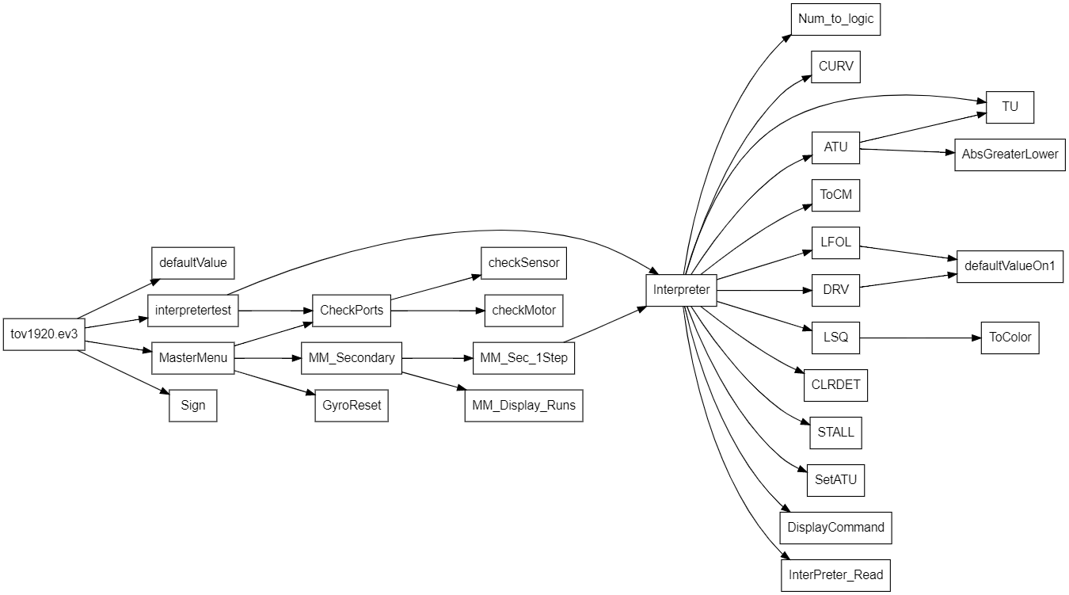The main features we can't perform with one green block are included in MyBlocks to keep our program not long but transparent especially MasterMenu because we don’t really use the mindstorms programming environment to handle our robot.  
Our often used MyBlocks are named targeted, short, unique names (eg DRV, TU, ToCM, etc…). This is done because of simplicity and transparency, optimization / * and to make the interpreter we want to use easily. * /In our programs we use a lot of loop and switch.

We use subordinated MyBlocks in MasterMenu main program for transparency and efficiency.  
When we start the robot, there is another side outside the robot run where we can reset the gyros and everything else.

In previous years, there were several times that we had unnecessary variables in our project and these slowed down the robot, so this year we reviewed the final project with the tool called Ev3TreeVis and we could filter out the useless variables what left in it.

**Autonomy**

Goal: robot acts autonomous all the time, without intervention

Goal: robot acts autonomous all the time, without intervention

When we just had possibility, adjusted to the wall, for this reason don’t need to intervene. We navigate like, we accentually do not collide to the task models.

By using „DRV” Myblock we can easily, but more precisely do moving straight.

With the „TU” Myblock easy and accurate the turn. Usually we go next to the wall, because the move is straighter.

We don’t have to save our robot from the mat because it can navigate autonomously

**We always go that route which is the safest to our robot.**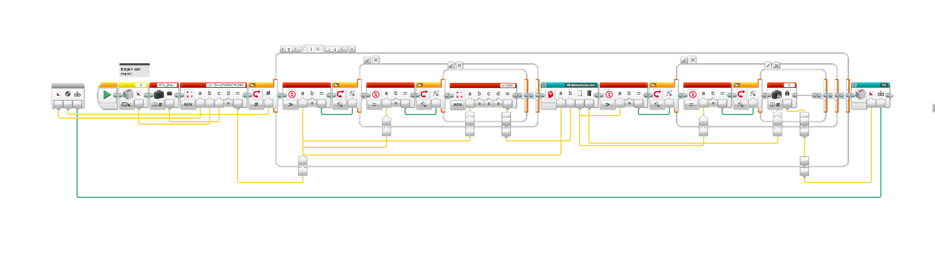

**Independence and navigation**

If we have the opportunity we align to the wall, therefore we don't need intervention. We navigate to don't get into any model. We use two gyro sensors to make the navigation more precise.

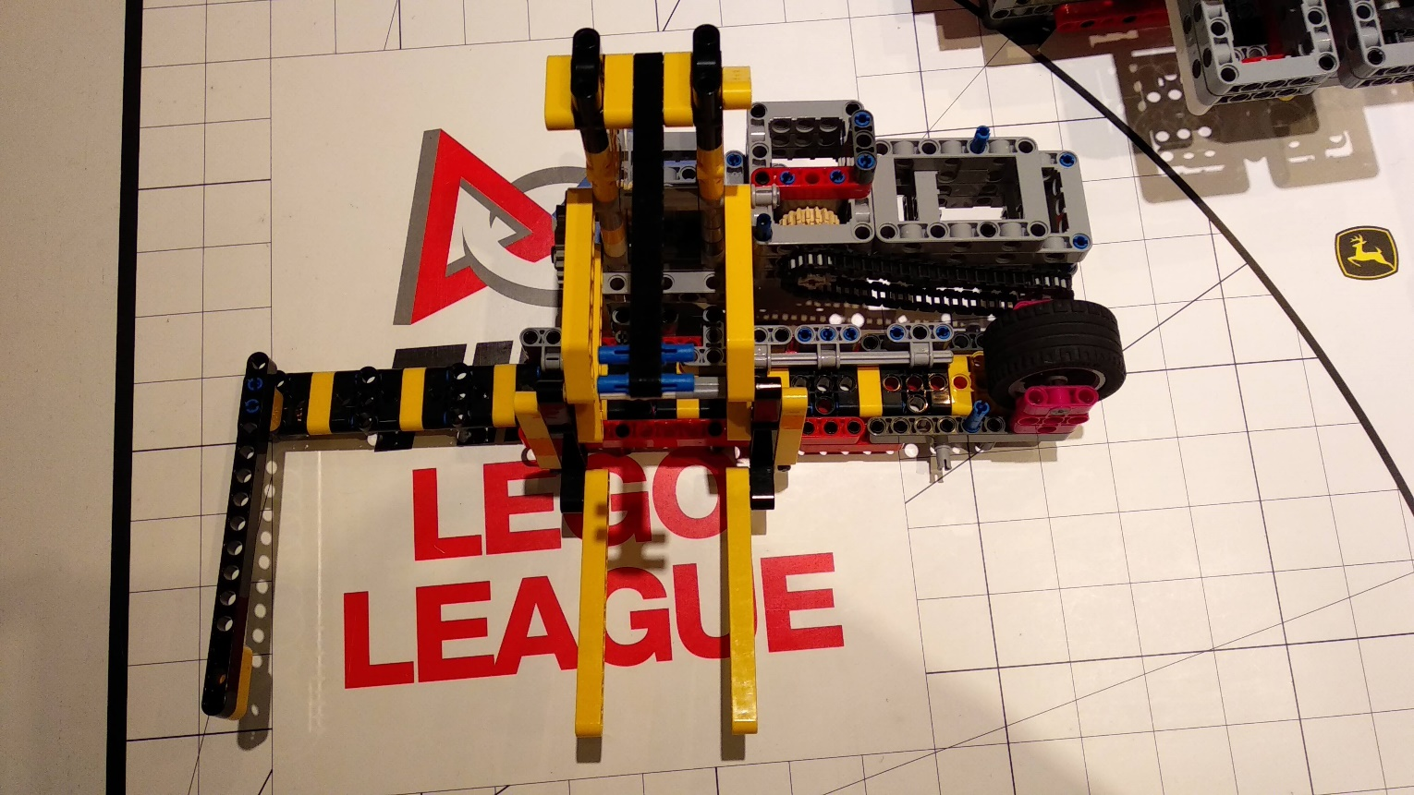With **"LFOL" Myblock** we can easily find a line and navigate on it very precisely but if this doesn’t work (what is very rear) we can restart the round easily

With **"TU" Myblock** we can easily and accurately turn.

We go next to the wall in many rounds, that move as straight as possible.

We always try go on the way, that is the **safest** for our robot.

**Sensor usage/ Location**

Our goal: using varied sensors for navigation

Our goal: using varied sensors for navigation

In total the robot is equipped by 4 (5) sensors: 1 gyro and 3 color sensors and (1 infra).

**Color sensors**

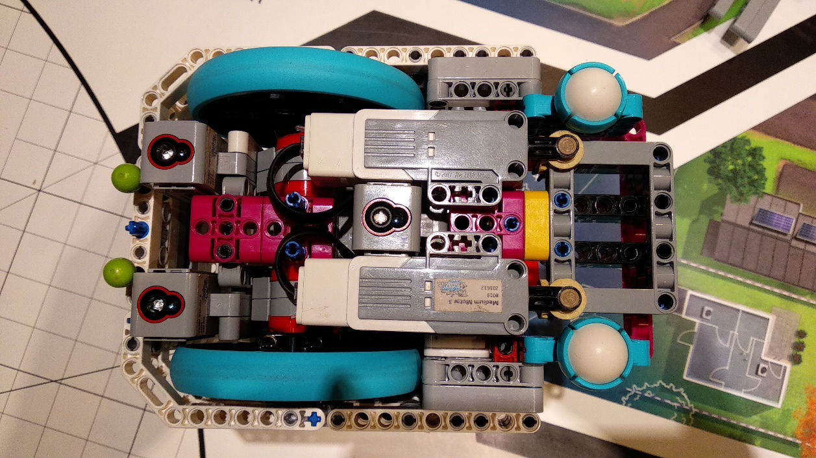They are fixed, we used all three tied-down points of the sensors. The two color sensors are used for accurate positioning and positioning to the line. They can be found at the back and the bottom of the robot, this allows them to perceive colors accurately. The third can be found at the center, bottom of our robot and is used for line following. The distance between the centers of the two sensors is 7 cm or 9 units. We use them in myblocks e.g. LFOL. We use them in reflected-light mode.

**Gyro sensor**

They are used for the accurate positioning of the robot. Positioning of the sensor: In the inner-center. It is used in TU and ATU (absolute turn)

**Infra sensor**

**WE DO NOT USE IT IN THE ROBOT RUNS!!**

We used this to test our attachments without programing, so we know it will work in live too.

|  |  |  |  |  |  |  |  |
| --- | --- | --- | --- | --- | --- | --- | --- |
| STALL |  | |  |  |  | Stops the robot when it can't move | STALL |
| CURV | Angle | | Speed | Steering | Mstop | Can move the robot to the adjusted angle with the adjusted steering | CURV |
| TU | Angle | | Mstop |  |  | Turns the robot to the adjusted angle with calculated speed | TU |
| DRV | Cm | | MaxSpeed | K(1.2) | Mstop | Moves forward to the adjusted Cms with calculated speed and with Gyro correction | DRV |
| ToCM | Cm | | Speed(-) | Steering | Mstop | Moves the robot to the adjusted Cms with the adjusted speed | ToCM |
| LFOL | Cm | | Port | Speed(-15) | K(1.1) | follow line with both sensors for a number of degrees, or seconds, or until both sensors see black or specific sensor sees black. | LFOL |
| --LSQ | Direction | |  |  |  | Adjust the robot to a line*/ | --LSQ |
| ATU | Angle | | Direction | Mstop |  | Absolute value turning. Dir: 1 - right, -1 - left, 0 - shortest | ATU |
| MedSec | Port | | Speed | Sec for run |  | Default green block | MedSec |
| MedRot | Port | | Speed | Rotation |  | Default green block | MedRot |
| MedOn | Port | | Speed |  |  | Default green block | MedOn |
| WaitSec | Sec | |  |  |  | Default orange block | WaitSec |
| LrgSec | | Steering | Speed | Sec for run |  | Default green block | LrgSec |

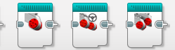**Subroutines/ Loops  
/ Variables**

Our goal: meaningful use of variables, loops and myblocks

Our goal: meaningful use of variables, loops and myblocks

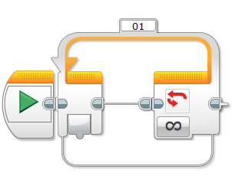 **Loops / Cycles, MyBlocks**

|  |  |
| --- | --- |
| **Loop név** | Hol? |
| **ValueOfScene** | MasterMenu |
| **_MasterMenu** | _MasterMenuBandA |
| **_MasterMenuVezer** | MasterMenu |
| **_MMACancel** | _MasterMenuBandA |
| **_MMCancel** | _MasterMenuBandA |
| **01** | GyroReset |
| **01_MasterMenuIdozito** | _MasterMenuBandA |
| **01_MasterMenu_TeljesFutas_Idozito** | MasterMenu |
| **02_MasterMenu_TeljesFutas_Idozito** | MasterMenu |
| **DRV01** | DRV, CURV, STALL, ToCM |
| **TU** | TU |
| **LFOL** | LFOL |

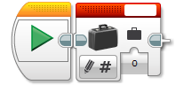

**INTERPRETER**

**INTERPRETER**

**Variables**

**Variables**

**Subroutines/ Loops / Variables #2**

**Subroutines/ Loops / Variables #2**

**Hierarchical   
program structure**

**Simplicity**

Our goal: Tasks easily solved

Our goal: Tasks easily solved

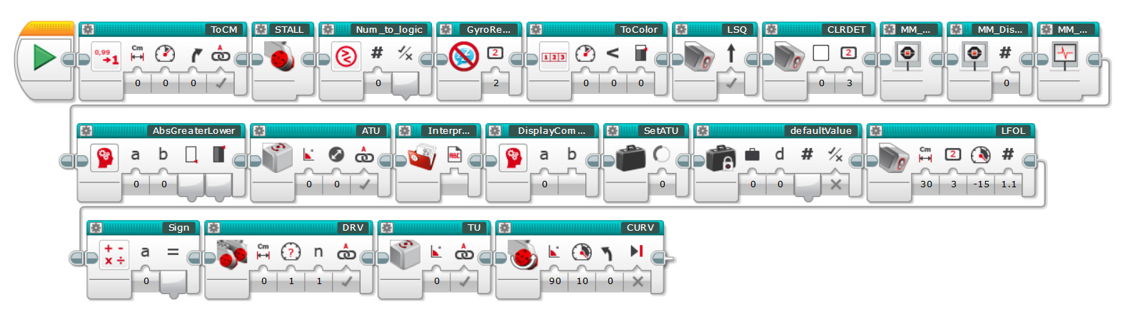 Our software is **easy-to-capture,** **understandable** and **well-structured**. Every MyBlock is indicated by a **clear icon,** because this way it is easily interpretable for **everybody**. We pay attention that the **parameters are indicated by appropriate signs.** In our project we love to use **comments**, because this way every robot move is easy to follow. We don’t complicate our rounds unnecessarily, we try to solve all the issues in the **simplest way**. To make our programing more **simple** and **understandable** we used an **Interpreter** with an excel interface and it is the **simplest** but most **accurate** we could make.

All Myblocks

Interpreter

# EV3 Text based interpreter

# Goal, Advantages/Disadvantages

We have created an interpreter for Ev3 mindstorms, because we can use Excel to write a program for our robot, but we still compile the text file we made with Excel with Ev3 Mindstorms. This is simpler. We prepared a program in Lego Mindstorms which can understand our text file as a robot program. Additional innovation is, we use 3 way paralell processing. So we can run not only 1 but 2 or even more blocks together in separate queue branches.

*Interpreter definition: An interpreter is a computer program that directly executes, i.e. performs instructions written in a programming or scripting language, without requiring them previously to have been compiled into a machine language program.*

|  |  |
| --- | --- |
| Advantages | Disadvantages |
| * Faster programming * Text-based programming * Easy-to-understand * Clean * Automatic fill * 3 parallel queue handling – but it could be endless (don’t need) * Way faster uploading and testing * Does not rely on the uncertain mechanics of mindstorms | * No loops/switches – workarounds possible   + Switch available: CLRDET |

# Excel User Interface

Credit goes to LOL team from 2011, Los Angeles – original version available on the internet, we added: **queueing, uploading to robot, starting on robot, saving in the MasterMenu format, autofill, commenting, 2 more variables, of course our own myblocks, 110 lines of code aprox., boolean handling, interface.**

Here you can type the command

Here you can type the command

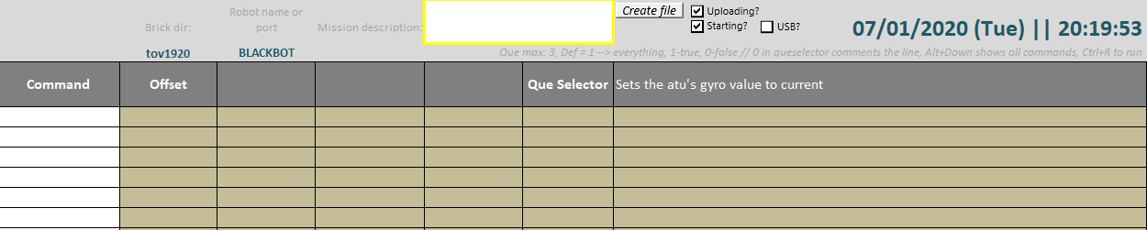

This button generates the text file

This button generates the text file

# Error Detection

If the command you type in, not exists, it will be red. But if it’s right the top text will turn into the currently used block’s parameters’ names. And you will also see the block’s little description.



# Instructions, list of commands

This page with the blocks, parameters and descriptions called “Instructions”.

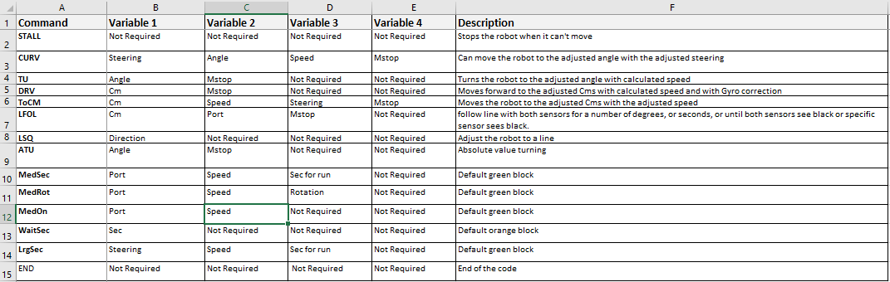

# The bridge mission encoded in interpreter

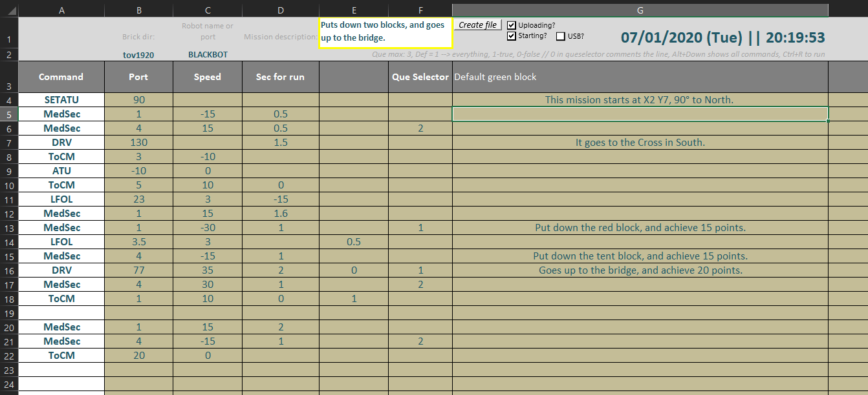

# Visual Basic implementation in Excel

## File making program Uploading and starting to the robot

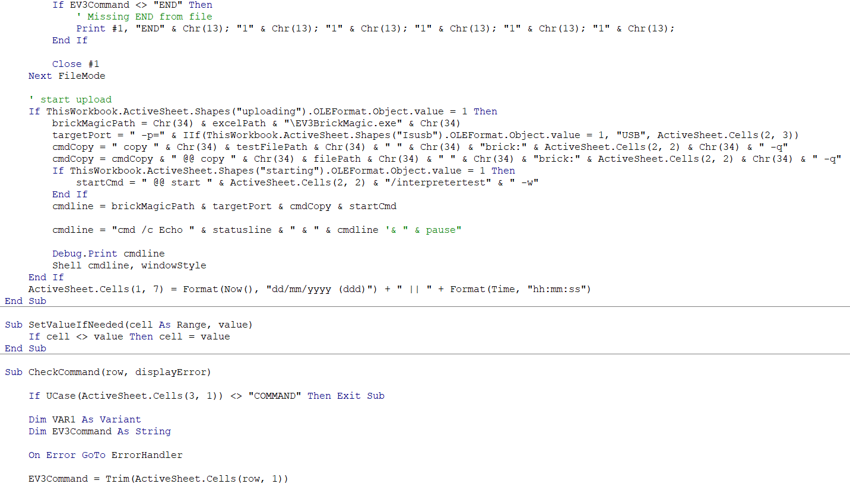

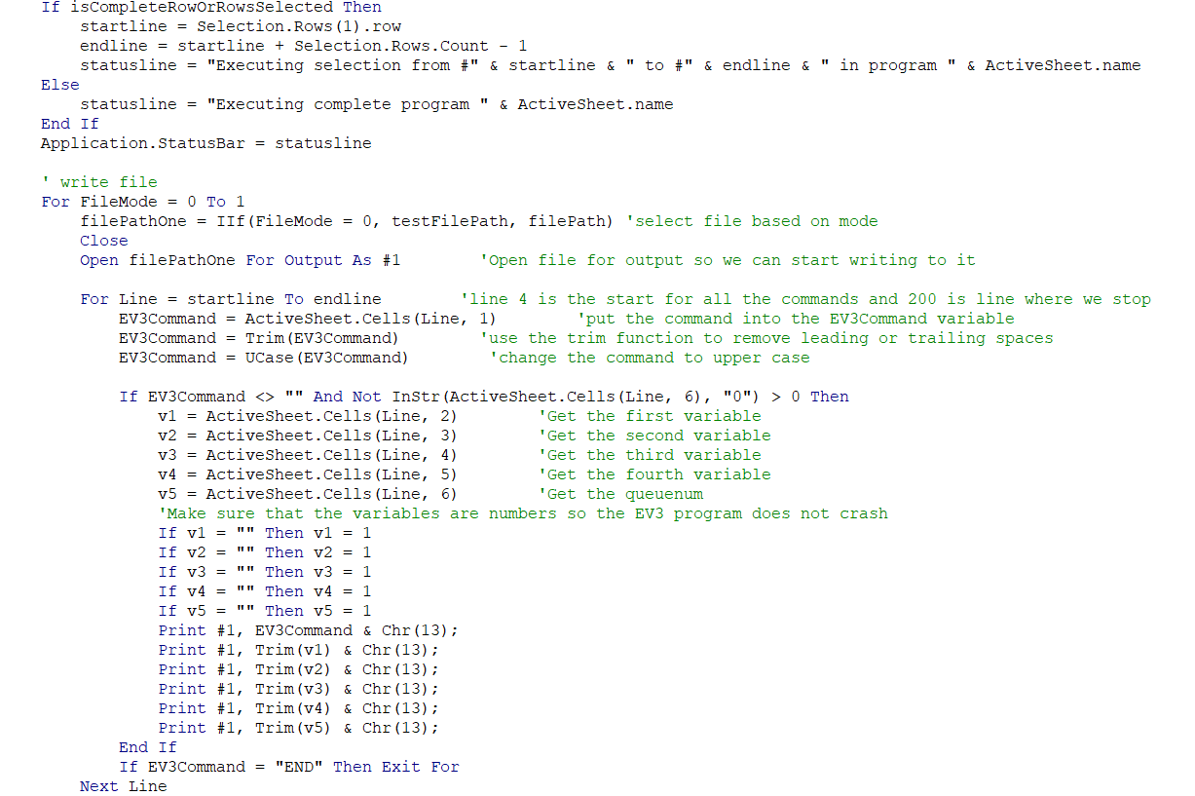

This is an “existing command check”

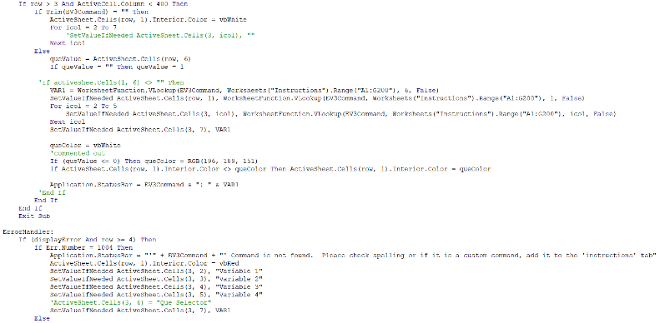

**Mission Strategy – SF**

**Mission Strategy**

Our goal: very clear, purposefully to maximize points

Our goal: very clear, purposefully to maximize points

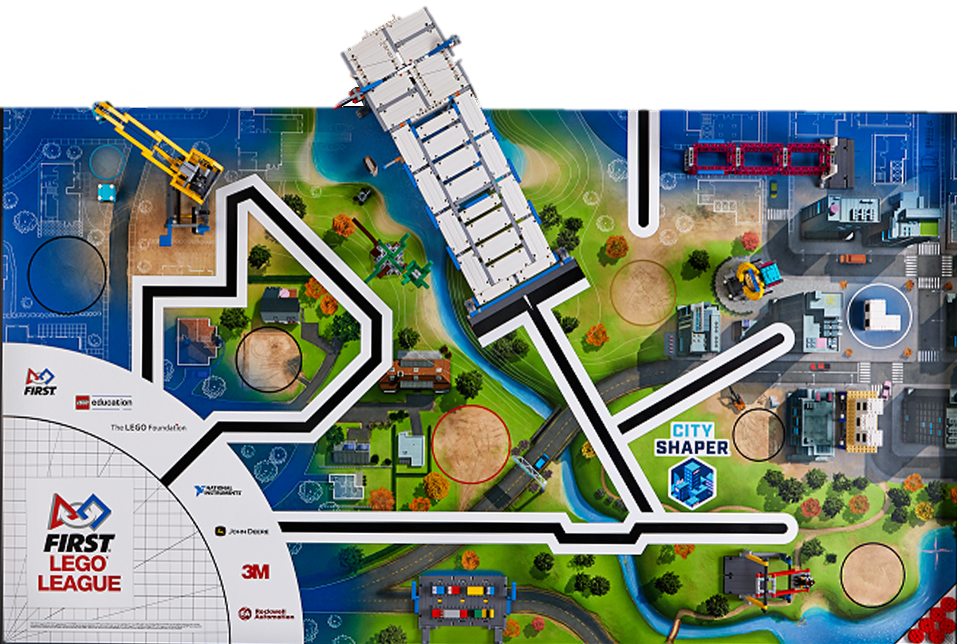

1.round: Design & Build(sumheight:21), Sustainability upgrades x3, Base

2. round: Crane, Design For Wildlife, Inspection Drone, Base

3. round: Traffic Jam, Swing, Safety Factor, Elevator, Innovative Architecture, Base

4. round: Design and Build(2 colors), Elevated Places

**Mission Strategy – Regional**

**Mission Strategy**



1.round: Design & Build(sumheight:21), Sustainability upgrades x3, Base

2. round: Crane, Base

3. round: Safety factor, Base

4. round: Traffic Jam, Swing, Innovative Architecture, Base

5. round: Design and Build(2 colors), Elevated Places

# Our EV3 Implementation

## With this myblock we are able to read the actual file.

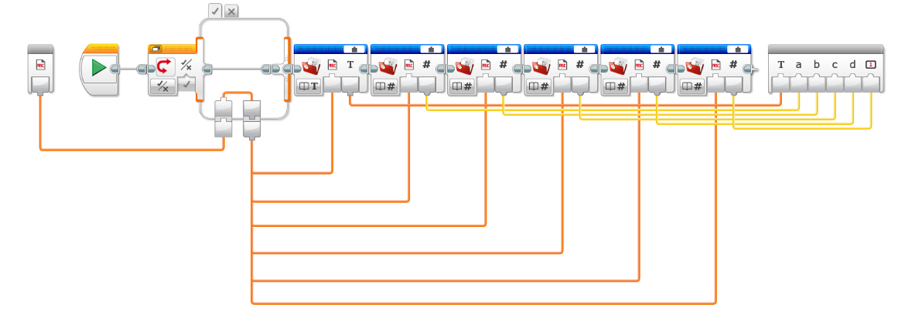

## This program can handle the output file and then can run the executed blocks

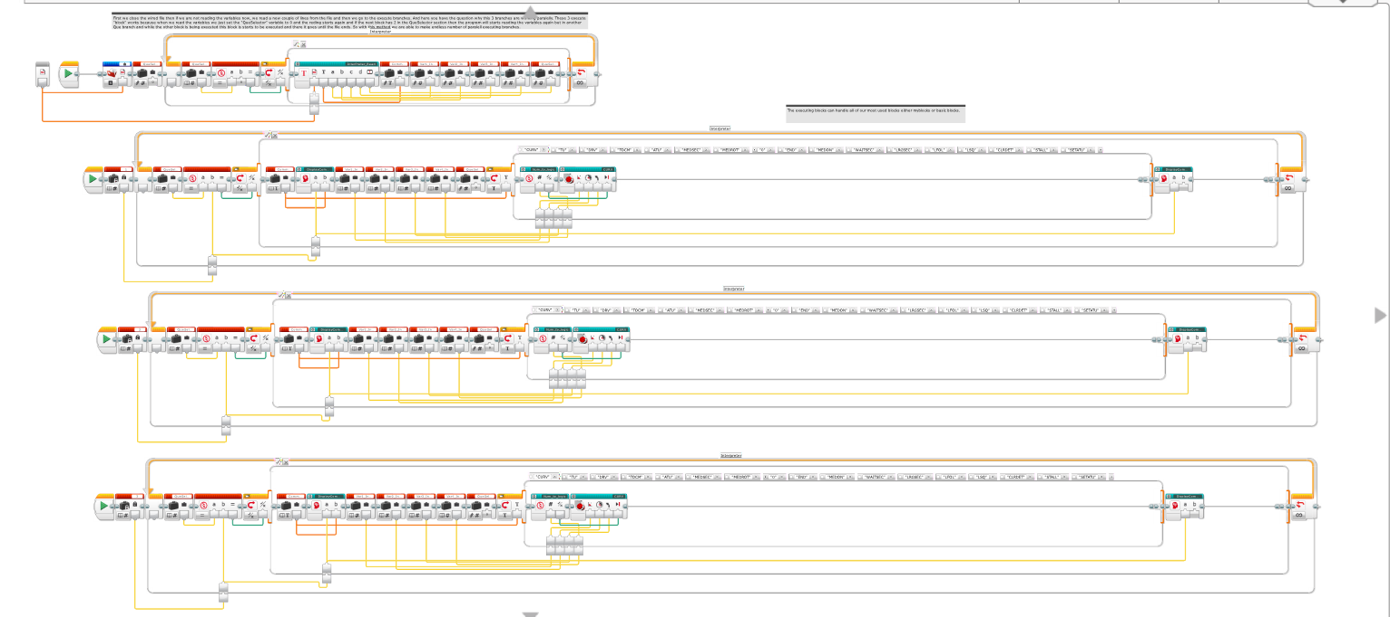

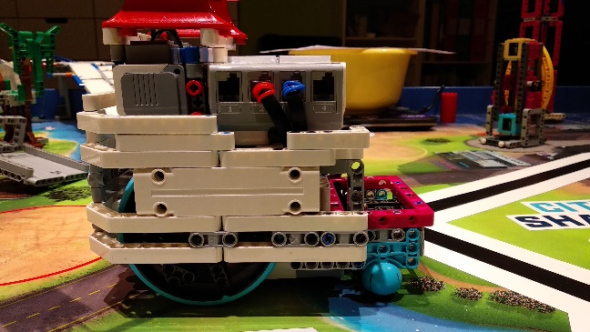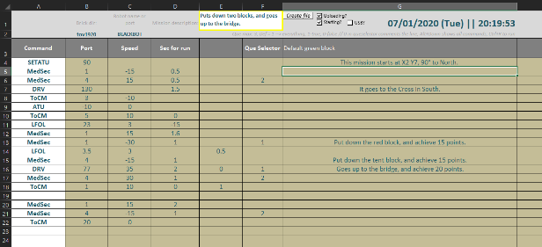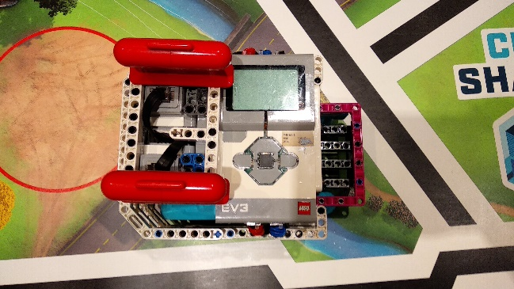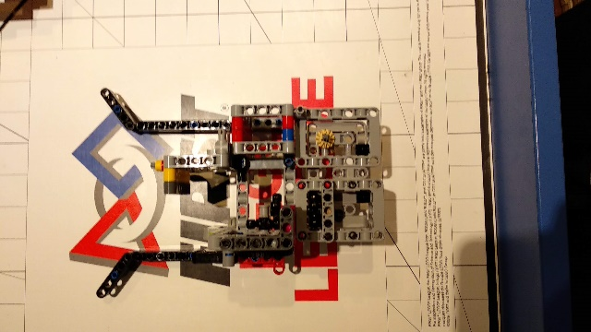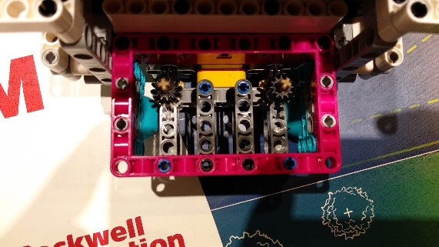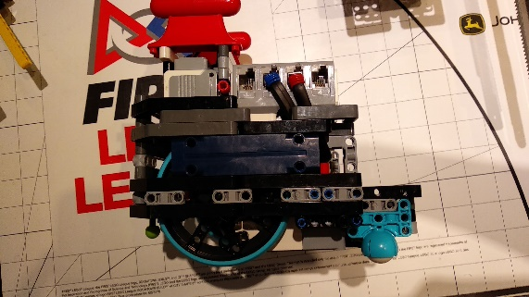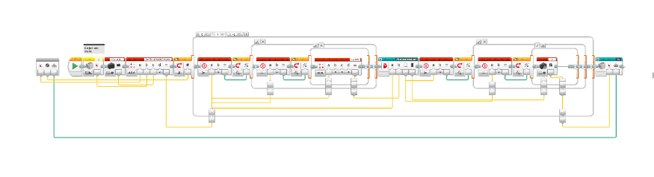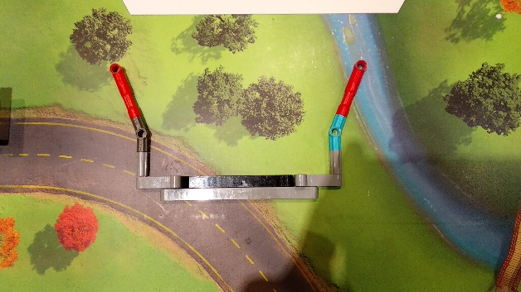

Our goal: robot designed by the team itself, unique, creative

Our goal: robot designed by the team itself, unique, creative

**Innovation Elements**

**Innovation Elements**

This year, we use a frontachment that isn’t attached to the robot but it’s on the front of it and this can help the robot to easily adjust to the bee model and then we can leave it there

We use solutions without motor drive. They do their task "passively". We use these to Crane, Design and Build, Innovative Architecture, Swing, Sustainability upgrades.

This year we placed our big motors vertically, because we could build a way smaller robot with it and small robot is good for this mat because the Advantage “mission” and because there a lot of places on the mat where only a small robot can fit in.

Our big innovation are the Spike elements in our robot especially the big wheels because they’re exactly the right size for our robot they’re strong so not really pushable, what is good when working with greater weights.

This year, we use a frontachment that isn’t attached to the robot but it’s on the front of it and this can help the robot to easily adjust to the bee model and then we can leave it there

We use solutions without motor drive. They do their task "passively". We use these to Crane, Design and Build, Innovative Architecture, Swing, Sustainability upgrades.

This year we placed our big motors vertically, because we could build a way smaller robot with it and small robot is good for this mat because the Advantage “mission” and because there a lot of places on the mat where only a small robot can fit in.

Our big innovation are the Spike elements in our robot especially the big wheels because they’re exactly the right size for our robot they’re strong so not really pushable, what is good when working with greater weights.

Our big innovation this year is the ATU myblock, which is good for turning to an absolute value in degrees and that’s good because we always know where to robot heads from the absolute north so this makes programming easier

Our other really big innovation is our Interpreter program what translates an excel file to a text file and automaticly uploads it to the robot and starts a program on the robot, that can understand the commands in the text file and can perform them.

In our attachments we use LEGO boat weights as counterweights, because they are heavy enough but they don't need too much space.

Our medium motor pass the rotation with an innovative solution using the new beam frame from Spike set. So with this we can build an attachment base lot faster than in previous years

Our big innovation this year is the ATU myblock, which is good for turning to an absolute value in degrees and that’s good because we always know where to robot heads from the absolute north so this makes programming easier

Our other really big innovation is our Interpreter program what translates an excel file to a text file and automaticly uploads it to the robot and starts a program on the robot, that can understand the commands in the text file and can perform them.

In our attachments we use LEGO boat weights as counterweights, because they are heavy enough but they don't need too much space.

Our medium motor pass the rotation with an innovative solution using the new beam frame from Spike set. So with this we can build an attachment base lot faster than in previous years